A correction for the thermal mass induced-errors of CTD tags mounted on marine mammals

Vigan Mensah¹, Fabien Roquet², Etienne Pauthenet², Baptiste Picard³, Christophe Guinet³
¹ Institute of Low Temperature Science, Hokkaido University, Sapporo, Japan
² Department of Meteorology at Stockholm University (MISU), Stockholm University, Stockholm, Sweden
³ Centre d’Etude Biologiques de Chize (CNRS), Villiers-en-Bois, France
Correspondence to: F. Roquet, roquet@misu.su.se

Abstract
The effect of thermal mass on the salinity estimate from Conductivity Temperature Depth (CTD) tags sensor mounted on marine mammals is documented here and a correction scheme is proposed to mitigate its impact. The algorithm we developed allows for a direct correction of the salinity data, rather than a correction of the sample’s conductivity and temperature. The amplitude of the thermal mass induced error on salinity and its correction are evaluated via comparison between data from CTD tags and from Seabird Scientific © CTD used as a reference. Thermal mass error on salinity appears to be generally of order O(10⁻²) g kg⁻¹ , may reach O(10⁻¹) g kg⁻¹ in exceptional cases, and tends to increase together with the magnitude of the temperature gradient within the water column. The correction we propose yields an error decrease of up to 70% if correction coefficients specific to a given CTD tag are calculated, and up to 50% if a default value for the coefficients is provided and is valid for both fully resolved profiles and low-resolution data sent via satellite.

1. Introduction
The Conductivity-Temperature-Depth Satellite Relay Data Loggers (CTD-SRDL) tags (referred as "tag" in the following), developed at the Sea Mammal Research Unit (SMRU, St Andrews, UK) and routinely deployed on various species of seals (such as Southern elephant seals Mirounga leonina, Steller sea lions Eumetopias jubatus, or Ribbon seals Histriophoca fasciat) represent a tremendous source of hydrographic data in largely under-sampled areas such as the Southern Ocean, or the northern subpolar regions (Roquet et al. 2014, Treasure et al. 2017). The temperature and conductivity sensors fitted on tags, manufactured by Valeport Ltd. (Totnes, UK), yield high precision ($±0.005$ for temperature and $±0.01 mS/cm$ for conductivity, see Boehme et al. 2009) and reasonable accuracies ($±0.02$ for temperature and $±0.03$ for salinity) after delayed-mode calibration (Roquet et al., 2011). However, as will be demonstrated thereafter, the tags are affected by a thermal mass error -a phenomenon due to the transfer of heat from the sensor’s walls to the sample being measured- on both their temperature and conductivity cells. Salinity being estimated via measurements of conductivity and temperature, the error in these measurements reflects on the salinity estimation, which displays large discrepancies. The thermal mass phenomenon and its effect on salinity estimates have been well documented for the Seabird Scientific © SBE4 conductivity sensor (Lueck, 1990) and manifests in areas of large temperature gradients, such as the seasonal thermocline, as large salinity spikes of O(10⁻²) psu to O(10⁻¹) psu, followed by a slow decaying hysteresis. A correction model has been developed by Lueck and Picklo (1990), and adjustments to the correction coefficients have subsequently been implemented by Morison et al. (1994), Mensah et al. (2009) and Garau et al. (2011). In this paper, we first document the effects of the thermal mass error on the tags data by comparing results of temperature, conductivity and salinity profiles obtained simultaneously by tags and by SBE CTDs attached together on the same frame. We then develop and implement a thermal mass correction model loosely based on Lueck and Picklo (1990) -but applied directly on the salinity data- and we estimate its effectiveness on our comparison dataset. The data tested for documenting the initial error in salinity and its correction have been sampled under various hydrographic and thermocline conditions. We can therefore correct each tags data with two different sets of correction coefficients: (1) a set of coefficients optimized for each specific tag sensor, and (2) a unique set of coefficients valid for any tag sensors and in any oceanic conditions.
The thermal mass error affecting the tags and the salinity correction method are introduced in section 2. Section 3 presents the implementation of the correction scheme, the comparison of corrected tags data vs. reference CTD data, as well as a discussion on the effect of the correction obtained with the different sets of correction coefficients. A summary and conclusion are presented in section 4.

2. Thermal mass induced-errors and its correction for CTD and tags sensors.
2.1. Theory
The thermal mass is a well-known phenomenon which affects primarily the conductivity cells of various CTD sensors, especially when the cell is unpumped as in CTD-SRDLs. Inductive conductivity cells are made of a cylinder through which the water flows as the CTD conducts its profile. Depending on the constructor, the cell is made of glass or ceramic and is typically surrounded by a layer of epoxy for protection. During profiling, the heat capacity of the sensor’s walls and protective layer causes heat to be stored within the sensor. This heat or “thermal mass” is exchanged through the sensor’s walls, thus contaminating the temperature and conductivity of the water sample. While the temperature is accurately measured by the CTD temperature sensor, the sample’s conductivity is modified due to the thermal mass, which yields a significant discrepancy in the salinity estimation. This error has been observed on the Seabird Scientific © SBE4 conductivity cell -which is part of the SBE9 CTD system- and depends on the temperature gradient (function of depth or time). It is particularly evident in situations of sharp thermocline (Lueck and Picklo, 1990; Morison et al., 1994; Mensah et al., 2009). This issue has been addressed in several works, with a thermal correction model developed by Lueck (1990) specifically for the SBE sensor. In that study, the thermal mass error is modelled as an error amplitude $α_{C}$, decaying within a relaxation time 1/$β$ (Lueck, 1990). The conductivity is then corrected via
$C_{T}\left(n\right)=Γ_{C}α_{C}{\left(1-0.5βΔ_{t}\right)}^{-1}T_{HP}\left(n\right)$, (1),
where $C_{T}$ is the correction of conductivity added to the conductivity of the n^{th} sample, $T_{HP}(n)$ is the high-pass filtered sample’s temperature (see Eq. (A4) Appendix I), using a first-order discrete-time filter with a time constant $τ=β^{-1}-0.5Δ_{t}$, n is the sample index, $Γ_{C}={\frac{∂C}{∂T}}_{S,p}$ is the coefficient of sensitivity of conductivity to temperature, and $Δ_{t}$ is the sampling time interval. This model has been successfully implemented with various sets of $α_{C}$ and $β$ coefficients for the SBE4. In the limit case $Δ_{t}β≪1$ (i.e. when the response time is much larger than the sampling interval), the correction simply becomes $C_{T}=Γ_{C}α_{C}T_{HP}$ with a time constant$τ=β^{-1}$ . Note that the formulation of the correction given here differs from the one given in Lueck and Picklo (1990), however both are formally equivalent as shown in Appendix I. The formulation given here is preferred because it is more readily interpretable in terms of a standard discrete-time high-pass filter.
The setting and technology of the tag sensor differ from those of the SBE4 cell, in that the wall of the conductivity sensor is made of ceramic for the tag instead of glass for the CTD cell, and the latter is an electrode cell whereas the tag cell is inductive. Despite these design differences, the tags are likely to show similar signs of thermal mass-induced anomalies due to the water sample passing through a few centimeters long pipe, itself covered by epoxy resin. The thickness of the epoxy layer is sensibly larger than on the SBE4 cell and, should the tag sensor indeed be affected by a thermal mass error, longer relaxation time than for the SBE cell are expected. Importantly, the Platinum Resistance Temperature sensor being located in the immediate vicinity upstream of the conductivity cell and surrounded by epoxy, a thermal mass error may also affect the temperature measurements, contrary to the SBE CTD.
Following Morison et al. (1994), temperature could be corrected in a similar scheme as conductivity according to
$T_{T}\left(n\right)=α_{T}{\left(1-0.5βΔ_{t}\right)}^{-1}T_{HP}\left(n\right)$ (2),
where the only formal difference with (1) is that no sensitivity coefficient is required in the case of a temperature correction.
2.2. Illustration of the thermal mass error on tags data
In order to assess the possibility of a thermal mass error affecting both the tags temperature and conductivity sensors, we tested the response of four tags to high temperature gradients in in-situ situations. As part of the “BOUSSOLE” program (Antoine et al., 2008) in the Ligurian Sea, the four sensors were attached together with a SBE9 CTD system, which is used as a reference. For each tag, a total of 7 casts were conducted. Each tag temperature, conductivity and salinity profiles are corrected for bias and pressure-induced slope following Roquet et al. (2011). The test was conducted at the BOUSSOLE mooring site (43°20’N, 7°54’E) in the northwestern Mediterranean sea, on board the SSV “Tethys II”. The experiment was carried out on the 11th and 12th of June 2008, during which a seasonal thermocline of gradient ~0.2°C.m⁻¹ was prevalent between ~10 m and ~50 m depth, and with local maximum gradient of ~0.6°C.m⁻¹. Our test is therefore suited for detecting and characterizing errors in a nearly idealized, step-like environment, as it was done in Lueck and Picklo (1990), Morison et al. (1994) or Mensah et al. (2009). The results of this experiment demonstrate that strong anomalies exist for both the temperature and conductivity, with a maximum error of order 10⁻¹ °C and 10⁻² ms.cm⁻¹ for temperature and conductivity respectively (Figures 1a and 1b). These errors reflect on the salinity estimation, yielding a maximum error of order 10⁻¹ psu (Figure 1c). While the scale of the temperature error will be shown to be exceptional due to the extreme magnitude of the temperature gradient, the order of magnitude for the conductivity error is usual for temperature gradients greater than 0.1°C m⁻¹ (section 3). Also, the rather extreme temperature gradients observed in this experiment are not unusual in some of the regions sampled by the marine mammals carrying the tags, such as the Okhotsk Sea (Nakanowatari et al., 2017).
Beside the typically large scaled and long-term thermal mass error, discrepancies of smaller scale and shorter-term are evidenced from the profiles of conductivity difference (Figure 1e) and temperature difference (Figure 1d). These errors do not show clearly on the profiles of temperature and conductivity, but manifest on the salinity profile (Figure 1c), as spikes of O(10⁻²) psu. Such high frequency error may be caused by the irregular flow within the tag sensors, as contrary to the SBE4 cell the tag is not fitted with a pump stabilizing the inflow. Variations of the tag platform’s speed could then affect the flow velocity and turbulence within the sensor, leading to slight changes of the sensor’s response to environmental changes within the water column.
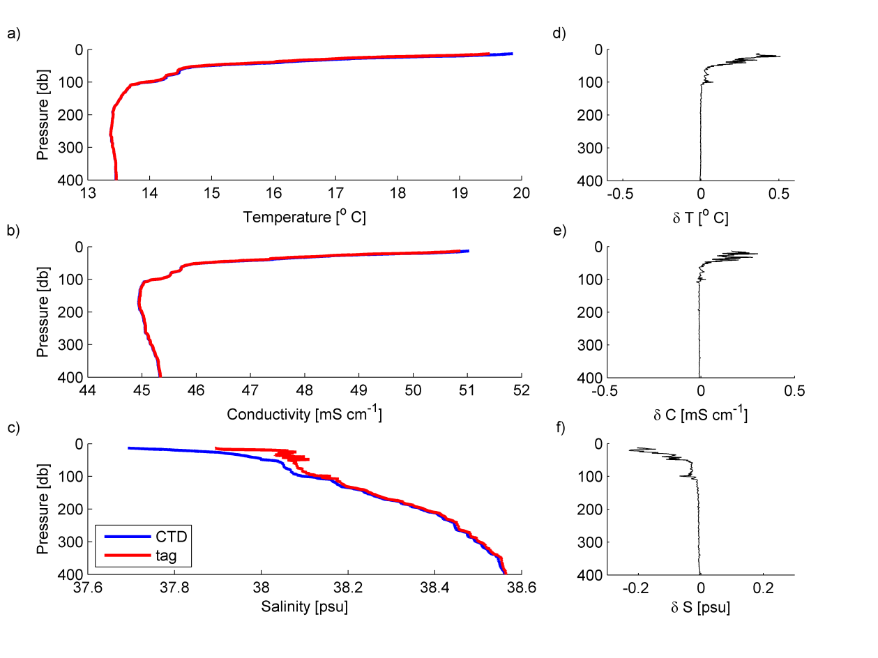
Figure 1. CTD-SRDL and reference SBE CTD cast acquired on 11 June 2008 at the BOUSSOLE mooring site. (a) Temperature profiles, (b) conductivity and (c) salinity. Panels, (d), (e) and (f) display the temperature, conductivity and salinity difference (CTD minus tag) between both sensors, respectively. The thermal mass error is characterized by the strong anomaly prevalent above the thermocline within the 50 upper meters.
2.3. An independent correction scheme for salinity
As a preliminary test, both the conductivity and temperature profiles of each of the 4 tags were corrected using (1) and (4) respectively, with the arbitrary values $α_{C}=0.05$, $α_{T}=0.037$ and $β=1/{120}$ s⁻¹. This test produced a significant reduction of the error (not shown) for the temperature, conductivity and salinity data of profiles such as the one displayed in Figure 1. However, correcting the temperature and conductivity separately may lead to an ambiguity in the correction of the salinity estimate. Residual discrepancies may remain due to various causes, e.g. misestimate of the coefficient values for the thermal mass correction or slight misalignment of the CTD and tag pressures, making it possible for the temperature and conductivity residual errors to compensate each other, and to yield a correct salinity estimate. Thus, the search for optimal correction coefficients for temperature and conductivity would be hampered by such considerations.
Finding a way to correct the salinity estimate directly becomes necessary, and a correction scheme based on (1) could be implemented following the small-amplitude assumption that the salinity correction is a linear combination of the effect of conductivity and temperature corrections:
$S_{T}={\frac{∂S}{∂C}}_{T,p}C_{T}+{\frac{∂S}{∂T}}_{C,p}T_{T}$ (3)
As the causes of the temperature and conductivity thermal mass are similar, the time constant $β^{-1}$ which are included in the correction schemes (1) and (2) are identical and we can establish the following salinity correction:
$S_{T}\left(n\right)=Γ_{S}α{\left(1-0.5βΔ_{t}\right)}^{-1}T_{HP}\left(n\right)$ (4),
where $Γ_{S}={\frac{∂S}{∂T}}_{C,p}$is the coefficient of sensitivity of salinity to temperature, at fixed conductivity and pressure. The validity of (4) is ensured if within the range of salinity measured, the deviation of $Γ_{S}$ is small. This is demonstrated in Figure 2a and 2b, which display the values of $Γ_{C}$ and $Γ_{S}$ at various values of temperature and conductivity (salinity), respectively. Applying temperature and conductivity corrections following Eq. (1) and Eq. (2) is equivalent to directly correcting salinity using Eq. (4) with an error magnitude $α=α_{T}-α_{C}$. One major drawback of correcting directly salinity instead of temperature and conductivity separately, however, is that it might lead to uncorrected biases in both the temperature and density. The magnitude of residual density errors will be discussed later in the study.

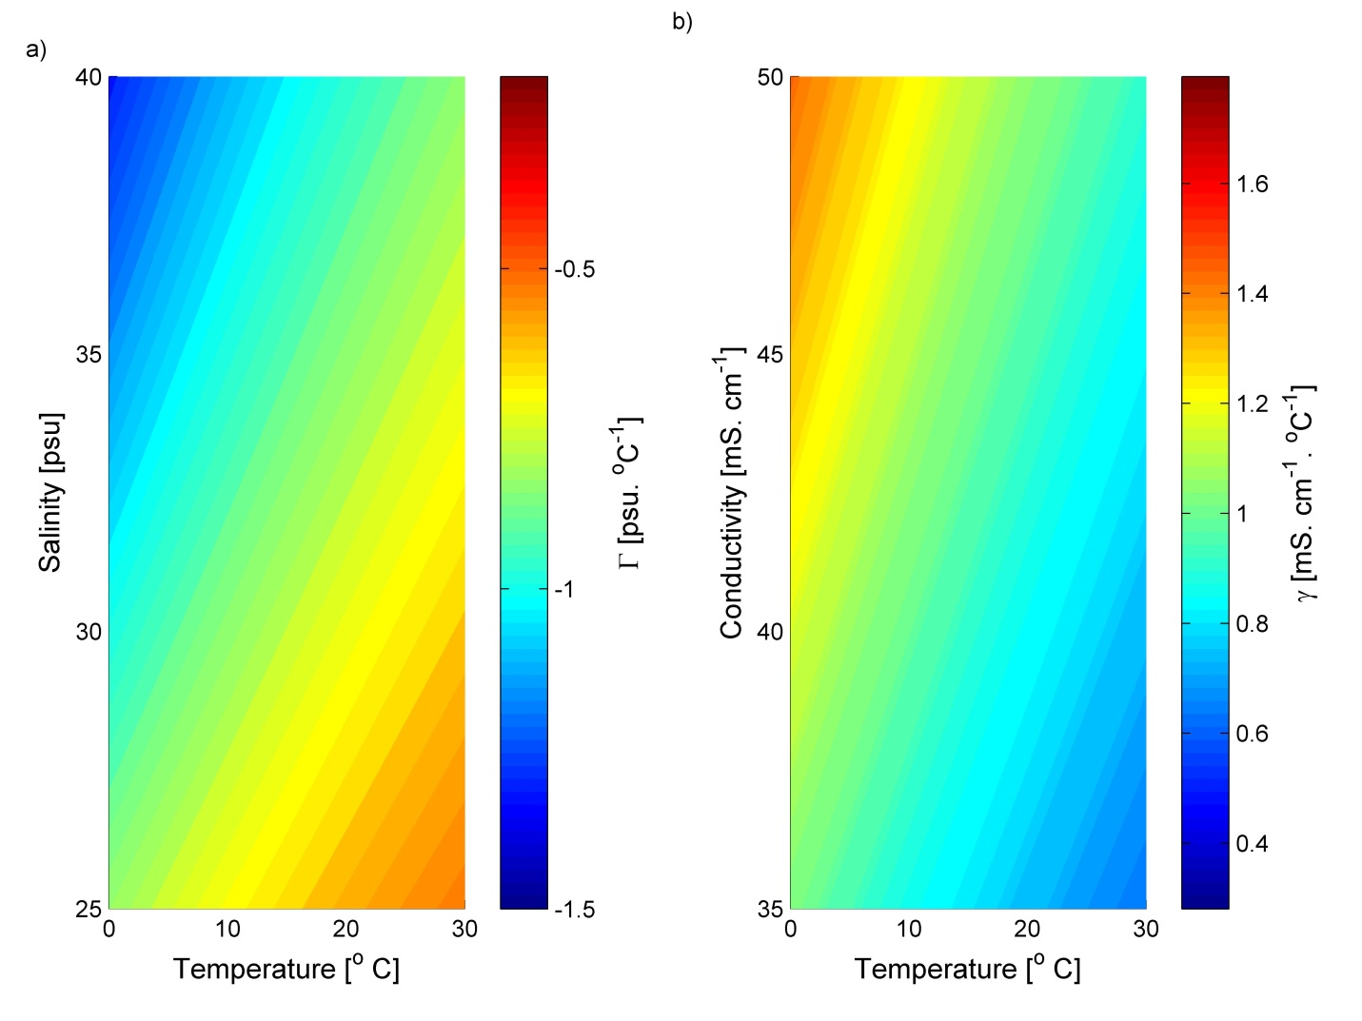
Figure 2. Values of the coefficients $Γ_{S}$ of sensitivity of salinity to temperature (a), and $Γ_{C}$ of sensitivity of conductivity to temperature (b), for various ranges of temperature and salinity, and temperature and conductivity, respectively.
Following the new standard recommendations, we use absolute salinity (McDougall et al., 2012) rather than practical salinity in our analysis, so that all salinity values displayed in the following figures and tables will be expressed as absolute salinity, in g kg⁻¹. Note that while the values in an absolute salinity profile are generally shifted by ~0.16 compared to those of a practical salinity profile, our correction scheme yields nearly identical results whether conducted on practical or absolute salinity profiles.

3. Results
3.1. Optimum range of the correction coefficients
a. Determination of coefficients
We collected data from five different calibration cruises, thereafter called “experiments” during which a set of tags is attached to a CTD frame and conduct profiles simultaneously with a SBE9 CTD system, used as a reference. Both CTD and tags data are processed following their respective standard post-processing procedure, the tags temperature and conductivity sensors pressure-dependent drift being previously corrected via the method of Roquet et al. (2011). We call “error” the root mean square (RMS) difference between the salinity obtained from the CTD and that obtained from the tags, before and after implementation of the correction scheme. The salinity correction delineated by Eq. (4) is tested through a least square regression scheme, in which we look for the pair $α_{opt},β_{opt}$ which minimizes the RMS error in salinity$F\left(α,β\right)$, where,
$F\left(α,β\right)=\sqrt{\frac{1}{N×nc}\sum_{i=1}^{i=nc}{\sum_{z=1}^{z=N}{{\left(S_{ref}\left(z,i\right)-S_{tag}^{α,β}\left(z,i\right)\right)}^{2}}}}$ (5).
The test was carried out separately for each of the n tags in order to obtain a set of optimum correction coefficient $α,β;$ z=1,2…N is the depth of the measurement (in dbar) with N=100, and i=1 , 2, … nc is the number of casts tested on a given tag. For conducting this test, we focused only on the upper 100 m of the water column since the strongest temperature gradients are observed within this depth range. During these five different experiments, we tested a total of 26 tags and 95 profiles. Experiments Boussole08 and Boussole09 were conducted in the western Mediterranean Sea at the BOUSSOLE mooring location in June 2008 and November 2009, respectively. Both of these experiments present strong thermoclines where the time temperature gradient largely exceeds 0.1°C.s⁻¹, and where tags data are expected to exhibit strong signs of thermal mass. Experiment Carols08 was conducted in the Bay of Biscay in November 2008 and presents only a moderate thermocline due to the strong winds occurring in the eastern Atlantic in the late autumn. Experiments Albion08 and Albion09 were conducted during the Austral summer in the Dumont d’Urville Sea, off the coast of Terre Adelie, Antartica. The environment for these experiments is characterized by water temperature between -1.9°C and +0.4°C and weaker temperature gradients than those encountered during the Mediterranean Sea or Bay of Biscay experiments. The values of the maximum temperature gradients encountered during each of these experiments are indicated in Table I.
b. Effects of the correction on salinity data
The value of optimum correction for each of the different experiments are indicated in Table I, where the correction D is defined as $D=F\left(0,0\right)-F\left(α,β\right)$ , $F\left(0,0\right)$ being the RMS difference between the CTD salinity and the uncorrected tag salinity. A positive (negative) value of D indicates an improvement (degradation) of the data quality.
The range of salinity error $F\left(0,0\right)$ is large, varying between O(10⁻²) g kg⁻¹ and O(10⁻¹) g kg⁻¹ depending on the experiment. In particular for the Boussole08 experiment -where the highest temperature gradients were encountered- the error reaches values as high as 0.108 g kg⁻¹ within the upper 40 meters. Conversely, the two Albion experiments, with their weaker temperature gradients, exhibit the smallest salinity error (0.010 g kg⁻¹ and 0.018 g kg⁻¹ respectively). Our results suggest that significant discrepancy between tag and CTD can be expected for temperature gradients exceeding 0.1 °C m⁻¹ (Table I), with error values exceeding 0.030 g kg⁻¹ for temperature gradients in excess of 0.3 °C s⁻¹. This apparent relationship between the magnitude of the gradient and that of the error implies that most of the salinity error is due to the thermal lag effect affecting the tag sensors. This assumption is confirmed by the results of Table I, which demonstrate that the correction scheme of (Eq. 4), used with properly chosen coefficients, systematically yields a significant reduction of the salinity error (Figure 3). Within the upper 100 m of the water column, the error is decreased by at least 45% for the three experiments whose error is the largest. In contrast, the remaining two experiments (Albion08 and Albion09) which present the lowest temperature gradient and initial salinity error, see their error decrease by one order of magnitude less. In these cases, the $F\left(0,0\right)$ value of 0.010 g kg⁻¹ and 0.018 g kg⁻¹ represent nearly irreducible errors, considering the accuracy of tag sensors. Similar observations are also valid for the upper 40 m of the water column, where the effects of the thermal mass error and its correction are more evident. In this area, 3 out of 5 experiments see their error decrease by at least 70% whereas the Albion08 and Albion09 profiles error only decrease marginally.
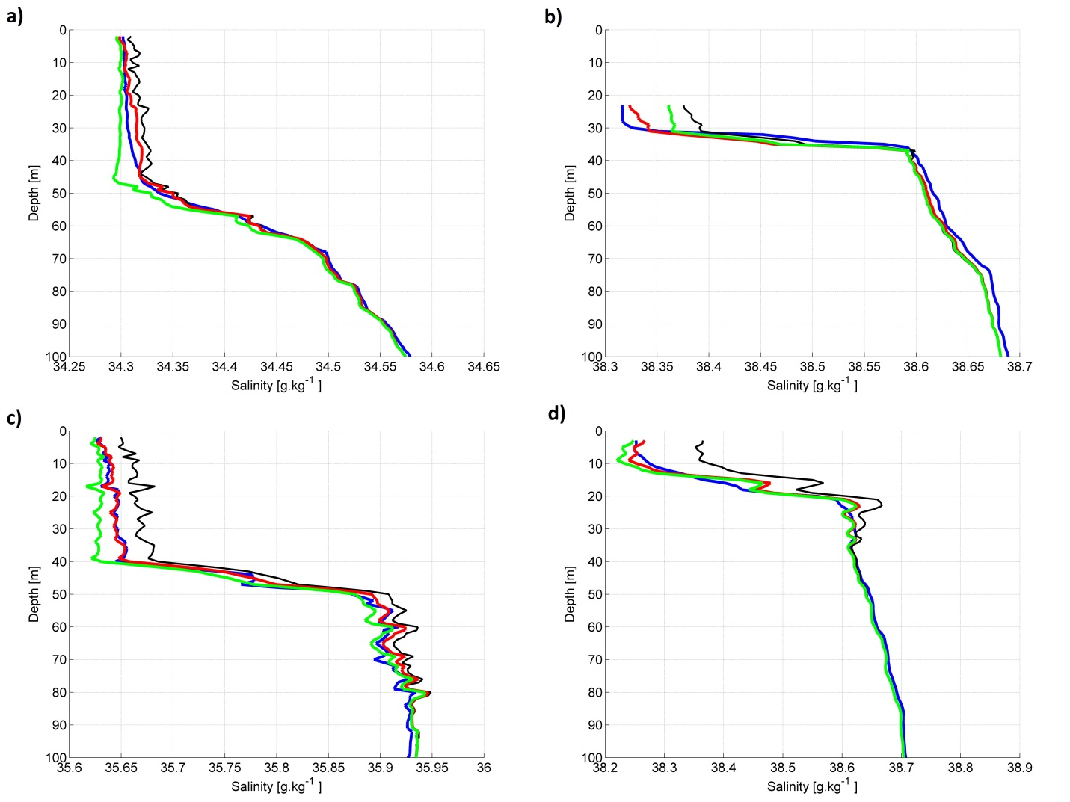
Figure 3. Reference CTD and typical tag profiles for 4 different experiments: a) Albion08 , b) Boussole09 , c) Carols08, d) Boussole08. The four curves on each picture represent the reference CTD profile (blue), non-corrected tag profile (black), tag profile corrected with a pair of optimum coefficients (red) and tag profile corrected with a pair of generic coefficients (green).
The salinity spikes in the uncorrected profiles of Figure 3a, 3c illustrate how the short-term errors possibly generated by the unstable flow within the conductivity cell (section 2.3) can further contribute to the salinity error. While this type of error may be absent in some cases (Boussole08, Boussole09), it contributes to a significant amount of the discrepancy for those cruises displaying a small initial salinity error such as the Albion08 and Albion09 experiments.
c. Impact of salinity correction on density error
In order to assess the potential contribution of uncorrected thermal lag errors on the temperature sensor on the density results, we estimate the values of initial and corrected error for the density profile (Table I). A salinity discrepancy of ~0.01 g kg⁻¹ corresponds to an error of ~0.01 kg m⁻³ in density, therefore should thermal inertia only affect the conductivity sensor of the tag, a 1 to 1 ratio should be expected between the salinity and density errors. A comparison of the density and salinity errors for each tag (Figure 4, Table I) demonstrates that in most cases the deviations from this ratio are small, implying that only the conductivity cell is significantly affected by the thermal inertia in these situations. However, profiles presenting a very sharp thermocline (~0.5 °C s⁻¹) such as those of Boussole08 all exhibit a density error significantly larger than the salinity error, i.e. the temperature sensor is also affected by a significant measurement error in this case. The increase of the density error means that when the tag overestimates the salinity -as exhibited in all profiles of Figure 3 above 40 m depth- in the meantime the temperature sensor underestimates the temperature. This trend can be seen in most of the tags experiencing a larger temperature gradient and salinity error, as those tags have their density error located above the 1 to 1 ratio line. This suggest that although the effect of thermal mass on the temperature sensor is large only in extremely high temperature gradient conditions, the phenomenon nonetheless affects the temperature sensor in many instances, albeit with much less significance.
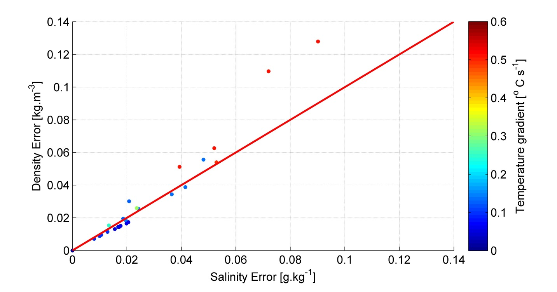
Figure 4. Comparative plot of salinity error vs. density error for each of the 26 tags tested. The red line represents the 1 to 1 ratio between the two errors and the color of each dot stands for the magnitude of the temperature gradient experienced by each of the tags.
d. Optimum coefficient values
The optimum coefficient values vary depending on the experiment, with $α$ ranging between 0.7% and 5.4% and the relaxation time ($1/β$) ranging between 19 s and >250 s. The reason for the particularly large range of values for the coefficient β is still unclear, but it may involve the presence of shallow thermoclines in some of the experiments meaning that the thermal lag response is still large when the surface is reached. There is no evidence that the magnitude of the temperature gradient may be the determining factor for the value of β, as the two experiments which present the largest temperature gradient, Boussole08, and Boussole09, are optimally corrected with very large and very low β values, respectively. Conversely the data from the Carols08 experiment, during which relatively small gradients were encountered, are optimally corrected with a rather large β coefficient (short relaxation time). For the Albion08 and Albion09 experiments however, the low value for both the $α$ and β coefficients may be explained by the low temperature gradient and minimal error. In these cases, we may assume that no significant correction being needed, the best results could be obtained with a very mild correction, i.e. a very small initial error and a particularly long relaxation time. In general, and as will be further discussed thereafter, the wide range of β coefficients for the different experiments suggests that an additional constraint may be needed to improve our correction model.
Table 1. Salinity correction statistics per experiment: temperature gradients, error magnitude, values of $α_{opt},β_{opt}$ coefficients for each experiment, averaged magnitude for both the optimum and generic correction in terms of salinity and density, with standard deviation indicated between brackets. The error and correction magnitude are displayed for both the upper 40 m and 100 m of the water column.
 |  |  |  | Salinity, 0 m-40 m |  |  | Density, 0 m – 100 m |  | Density, 0 m – 40 m
Experiment | Tags tested (number of profiles) | Temperature gradient  (°C m⁻¹) | $α_{opt}$ ,  $$β_{opt}$$  (averaged) | Error  (g kg⁻¹) | Optimum correction  (g kg⁻¹) | Generic correction  (g kg⁻¹) | Error  (g kg⁻¹) | Optimum correction (g kg⁻¹) | Generic correction  (g kg⁻¹) | Error  (kg m⁻³) | Optimum correction (kg m⁻³) | Error  (kg m⁻³) | Optimum correction (kg m⁻³)
Boussole09 | 3  (12) | 0.15 | 0.029, 0.004 | 0.030 | 0.017 (0.016) | 0.005 (0.003) | 0.040 | 0.027  (0.022) | 0.006  (0.002) | 0.032 | 0.012 (0.011) | 0.045 | 0.022 (0.018)
Carols08 | 7  (19) | 0.35 | 0.020, 0.042 | 0.030 | 0.014 (0.009) | 0.004 (0.019) | 0.027 | 0.019 (0.016) | 0.004 (0.027) | 0.032 | 0.012 (0.009) | 0.027 | 0.018 (0.015)
Albion08 | 5  (15) | 0.1 | 0.004, <0.001 | 0.010 | 0.002  (0.001) | -0.004  (0.003) | 0.012 | 0.003  (0.002) | -0.005  (0.005) | 0.009 | 0.002  (0.001) | 0.011 | 0.003  (0.002)
Boussole08 | 4  (28) | 0.51 | 0.054, 0.043 | 0.064 | 0.042 (0.018) | 0.031 (0.007) | 0.108 | 0.075 (0.034) | 0.055 (0.011) | 0.088 | 0.041 (0.015) | 0.151 | 0.071 (0.025)
Albion09 | 7  (21) | 0.06 | 0.007,  <0.001 | 0.018 | 0.002 (0.002) | -0.001 (0.002) | 0.027 | 0.004 (0.002) | 0.001 (0.003) | 0.015 | 0.002 (0.001) | 0.023 | 0.003 (0.002)

3.2. Generic correction coefficients
a. Determination of coefficients
In order to determine a set of generic coefficients, we adapted the method delineated by (Eq. 5), setting nc=60. The nc includes 12 randomly chosen profiles from each of the five cruises, in order to avoid a bias generated by the different number of profiles tested during each experiment. This test is repeated 200 times and we average the results to obtain the value of the salinity correction associated with each pair of $α$ and $β$ coefficients within the ranges defined in (Eq. 4) (Figure 5). The pair of coefficients yielding the maximum salinity correction becomes our generic coefficients (black cross on Figure 5). The coefficients obtained via this method are $α_{gen}=0.030$, and $β_{gen}=0.030s^{-1}$, or an initial error of 3.0 % and a relaxation time of ~ 33 s, and yield an average correction of 0.011 g kg⁻¹ out of an original averaged error of 0.038 g kg⁻¹.
a. Effects of the generic correction on salinity data
Figure 5 displays the salinity error, as defined in Table 1, as a function of the high pass filtered temperature T_{HP} for both the uncorrected and corrected version of the datasets. The figure illustrates well how quick variations of temperature affect the salinity data quality. The data presenting minimal variations of temperature (0.00°C <T_{HP}<0.02°C) are associated with a seemingly irreducible salinity error of ~0.02, and the correction only has a negligible effect on these data. Both the error and the effect of the correction increase together with the T_{HP}, with the error of the uncorrected data close to 0.1 for 0.05°C < T_{HP} < 0.1°C , and largely exceeding 0.1 for higher values of T_{HP}. The corrected salinity however only exceeds 0.1 for 0.22°C<T_{HP}<0.24°C, interval for which few data are available, as indicated by the large standard error at this interval. The error decreases between 30% and 40% of its initial value for the largest part of the T_{HP} range and by nearly 50% for the highest values of T_{HP.} This implies an increasing effectiveness of the correction together with the temperature gradient, as can be seen from the data in Table I. The set of generic coefficients performs particularly well for the Boussole08 dataset which exhibit the strongest temperature gradient. In this case, nearly 50% of the error is resorbed through the use of generic coefficients, figure which compares well with the ~70% error decrease obtained with the optimum coefficients. Aside from this experiment, the improvement brought by the generic coefficients is more modest but still significant when the initial discrepancy is high. The salinity data from Boussole09 and Carols09 are corrected by about 15% over the 40 and 100 upper meters of their profiles (Table I). The relatively high standard deviation for the correction value of the Carols09 experiment demonstrates however that the changes brought to the profiles are unequal in quality depending on the tag it applies for. On the lower end of the salinity error range, the generic set of coefficient yields either insignificant improvement or, in the case of Albion08, a moderate degradation of the data. In this case, illustrated in Figure 3a, the maximum discrepancy of ~0.03 g kg⁻¹ is reached around the halocline at 45 m depth and indicates an overshoot of the correction. This overshoot is resorbed following the halocline as the tag and CTD profiles converge from ~40 m depth to the surface. 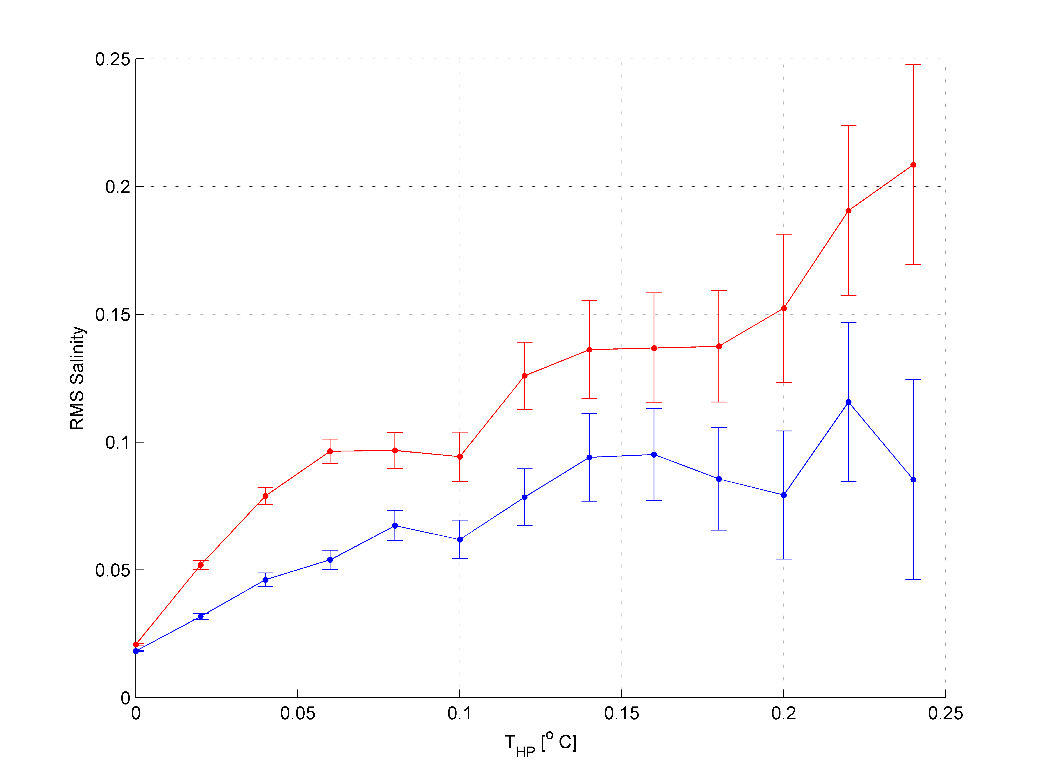
Figure 5: Root mean Square (RMS) difference of reference and tag salinity as a function of the high pass filtered temperature T_{HP}, calculated from all the data points located within the upper 100 m for the five experiments mentioned in this study. The red and blue curves stand for the uncorrected and corrected data (using the set of generic coefficients), respectively. The error bars represent the standard error of the estimate.
b. Generic correction coefficient values
To understand the unequal performance of the generic coefficients according to the different experiments, we plotted the values of each optimum coefficient pairs over the chart of Figure 6. Besides the generic set of coefficient ($α_{gen}=0.030$, $β_{gen}=0.030s^{-1}$), the graphic in figure 6 allows to see a large beam - whose limits are defined by the 0.010 g kg⁻¹ isoline- within which pairs of coefficients yield a correction close to $α_{gen}$, $β_{gen}$. We can therefore assume that for our 5 different experiments, the ones whose optimum coefficients are located close to or within this beam will be well corrected by generic coefficients. This is the case for two of the Boussole08 and three of the Carols08 experiment, whose optimum coefficients are within the high-correction beam and where the generic coefficients provide a large correction (Table I). This should also be the case for the Nakanowatari et al. (2017) experiment, where the pair of optimum coefficient ($α_{Okh}=0.05$, $β_{Okh}=0.06s^{-1}$) was determined via a comparison of tag data and historical data from the WOA13 in the Okhotsk Sea, and yield a decrease of salinity error of 0.07 psu over the uppermost 20 m of the water column.
Conversely, those experiments whose optimum coefficients are located at a large distance from this beam will have their data more poorly corrected by our set of generic coefficient. While the uneven behavior of the generic coefficients on the different data sets should encourage users to determine their own optimum coefficients whenever possible, our results have shown that the generic correction is most useful to the tags salinity data when those cross temperature gradients greater than 0.1 °C s⁻¹, and are likely to yield a significant improvement of the data quality. On the other hand, the generic correction yields insignificant changes on the low temperature gradient/low error experiments, with occasionally some minor degradation of the tags salinity profile in the form of a slight overshoot right above the thermocline.
Interestingly, the beam-like shape of the salinity correction distribution indicates some level of compensation between the two parameters α and β resulting in very similar performances for a wide range of parameters. Hence, using the generic coefficients yields marginal improvements compared to the coefficients used in Nakanowatari et al. (2017), although the relaxation times differ by a factor 2. This might explain why optimal coefficients show such a wide range in relaxation times and points to the need of more experimental data in the future to better constrain the value of the correction parameters.
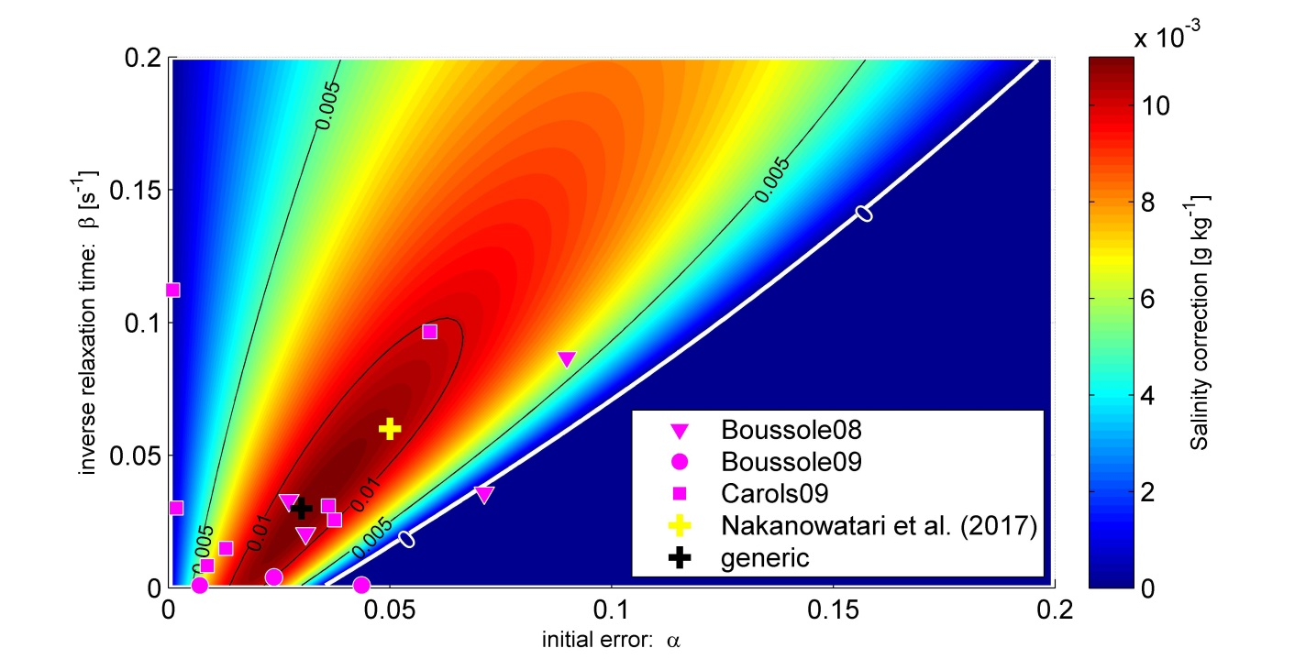
Figure 6. Salinity correction for different values of coefficients $α$ and $β$, with $F\left(α,β\right)$ calculated from all the casts of all experiments. The limit of null correction is represented with the white isoline and the various symbols represent the values of optimum coefficients for all the experiments with large temperature gradients tested in this study as well as from the experiment conducted by Nakanowatari et al. (2017).
4. Summary and conclusion
The SRDL-CTD tag sensors are subject to the thermal mass phenomenon which affects other conductivity cells such as the Seabird Scientific © SBE4. This paper has documented the effect of thermal inertia on the tags conductivity cell and provided evidence of thermal mass induced errors increasing with the magnitude of the temperature gradient within a profile. The conductivity discrepancy reflects on the salinity data, and a maximum salinity error of 0.108 g kg⁻¹ have been recorded for a temperature gradient of 0.51°C s⁻¹. Salinity estimate error may generally not be significant for gradients lesser than 0.10°C m⁻¹. As marine mammals on which tags are usually deployed routinely undertake profiles in area presenting O(10⁻¹)°C m⁻¹ temperature gradients, a correction scheme was developed to improve the salinity estimates. The main part of the correction methodology is a further development of the conductivity correction scheme of Lueck (1990). However, as the tag’s temperature sensor is also affected by thermal mass, which implies that to obtain an accurate estimate of salinity, both the conductivity and temperature data are to be perfectly corrected simultaneously, we developed a correction algorithm to be applied directly on salinity.
The correction algorithms are successfully implemented and tested on 26 different tags profiling in various hydrographic conditions and experiencing different ranges of temperature gradients and error. Comparison between tag profiles and CTD profiles conducted simultaneously allowed to calibrate the algorithm coefficients $α$ and $β$ for each of the tags. These optimum coefficients systematically lead to a significant improvement for all tags which crossed gradients greater than 0.1°C m⁻¹, with an error decrease of at least 45% and a maximum error decrease of 70%. A generic set of correction coefficient has also been determined for default use ($α_{gen}=0.030$, $β_{gen}=0.030 s^{-1}$), and is found to generate corrections ranging from 15% to 50% decrease of the original error for profiles presenting high temperature gradients. Moderate degradation of the data have been observed in some situations of low temperature gradients, although the magnitude of the correction in this case remain within the bounds of typical uncertainties in the salinity data. The determination of a set of generic coefficients may need further adjustment due to the limited number of tags data which it was determined with.
Lastly, while this paper documents the effects of our correction scheme on full-resolution tags data (1 Hz sampling rate), most of CTD-SRDL profiles available to date are heavily compressed due to satellite transmission constraints with a typical number of 20 data points per temperature/salinity profile (Boehme et al. 2009). The slow response nature of the thermal mass effect still brings hope that the correction will be useful on low-resolution salinity data. The thermal mass correction algorithm has already been successfully implemented on post-processed low-resolution data in the Okhotsk Sea and yielded excellent results (Nakanowatari et al., 2017). Users are therefore encouraged to apply the thermal mass algorithm on their low-resolution salinity data, which should yield a significant reduction of the thermal mass induced-errors.

Appendix I: Equivalence between the Lueck and Picko (1990) recursive filter and a standard first-order high-pass filter
Here it is shown that the recursive filter scheme devised by Lueck and Picko (1990) to correct the thermal mass effect on a measured variable X (conductivity in their case) is formally equivalent to a standard first-order high-pass filter applied on the temperature discrete signal, once suitably rescaled.
The recursive filter of Lueck and Picko (1990) is given by,
$X_{T}\left(n\right)=-bX_{T}\left(n-1\right)+Γ_{X}a\left[T\left(n\right)-T\left(n-1\right)\right]$, (A1),
where $C_{T}$ is the correction of conductivity added to the conductivity of the n^{th} sample, T is the sample’s temperature, n is the sample index, $Γ_{X}$ is the sensitivity of X to temperature, and a and b are coefficients depending of $α$ and $β$ according to:
$a=α/{\left(1+0.25β{f_{n}}^{-1}\right)}$ (A2)
and
$b=1-2aα^{-1}$ (A3)
where $f_{n}={(2Δ_{t})}^{-1}$ is the Nyquist frequency function of the sampling interval $Δ_{t}$.
Define the high-pass filtered temperature signal T_{HF} as,
$T_{HP}\left(n\right)=\frac{τ}{τ+Δ_{t}}\left[T_{HP}\left(n-1\right)+T\left(n\right)-T\left(n-1\right)\right]$, (A4),
where $τ$ is the time constant of the filter. Assuming that the correction is proportional to the high-pass filtered temperature signal, $X_{T}=AT_{HP}$, and neglecting variations of the factor $A$ between two consecutive samples (an excellent assumption in practice, see Figure 2), a relation can be found between equations (A1) and (A4) providing the two identities $b={-τ}/{\left(τ+Δ_{t}\right)}$ and $A=Γ_{X}a\left(1+{Δ_{t}}/τ\right)$. Using equations (A2) and (A3) and after some rearrangement, it comes that the recursive filter of Lueck and Picko (1990) is strictly equivalent to rescaling the high-pass filtered temperature signal $T_{HP}$using a time constant $τ=β^{-1}-0.5Δ_{t}$ and a factor $A=Γ_{X}α{\left(1-0.5βΔ_{t}\right)}^{-1}$.
Note that the filter is defined only if $β^{-1}>0.5Δ_{t}$, and that in the limit case $βΔ_{t}≪1$, the time constant of the filter tends toward $τ=β^{-1}$ and the correction simply tends toward $X_{T}=Γ_{X}αT_{HP}$.

Acknowledgments

REFERENCES

Antoine, D., Guevel, P., Desté, J.F., Bécu, G., Louis, F., Scott, A.J., Bardey, P., 2008. The “BOUSSOLE”buoy—A new transparent-to-swell taut mooring dedicated to marine optics: Design, tests, and performance at sea. Journal of Atmospheric and Oceanic Technology, volume 25(6):pp. 968–989.
Boehme, L., Lovell, P., Biuw, M., Roquet, F., Nicholson, J., Thorpe, S. E., Meredith, M. P., and Fedak, M., 2009. Technical Note: Animal-borne CTD-Satellite Relay Data Loggers for real-time oceanographic data collection. Ocean Science, 5:685-695.
Garau, B., Ruiz, S., Zhang, W. G., Pascual, A., Heslop, E., Kerfoot, J., and Tintoré, J., 2011. Thermal Lag Correction on Slocum CTD Glider Data. Journal of Atmospheric and Oceanic Technology, 28:1065-1071.
Le Menn 'About uncertainties in practical salinity calculations', Ocean Sci., 7, 651–659, 2011 ?
Lueck, R.G., 1990. Thermal inertia of conductivity cells: Theory. Journal of Atmospheric and Oceanic Technology, volume 7(5):pp. 741–755.
Lueck, R.G., Picklo, J.J., 1990. Thermal inertia of conductivity cells: Observations with a Sea-Bird cell. Journal of Atmospheric and Oceanic Technology, volume 7(5):pp. 756–768.
McDougall, T., Jackett, D., Millero, F., Pawlowicz, R., Barker, P., 2012. A global algorithm for estimating Absolute Salinity. Ocean Science, volume 8(6):pp. 1123–1134.
Mensah, V., Menn, M.L., Morel, Y., 2009. Thermal Mass Correction for the Evaluation of Salinity. Journal of Atmospheric and Oceanic Technology, volume 26.
Morison, J., Andersen, R., Larson, N., D’Asaro, E., Boyd, T., 1994. The correction for thermal-lag effects in Sea-Bird CTD data. Journal of atmospheric and oceanic technology, volume 11(4):pp. 1151–1164.
Nakanowatari, T., Nakamura, T., Uchimoto, K., Nishioka, J., Mitsudera, H., Wakatsuchi, M., 2017. Importance of Ekman transport and gyre circulation change on seasonal variation of surface dissolved iron in the western subarctic North Pacific. Journal of Geophysical Research: Oceans.
Roquet, F., 2011. Delayed-mode calibration of hydrographic data obtained from animal-borne satellite relay data loggers. J. Atmos. Ocean. Technol., volume 41:pp. 787–801.
Roquet, F., Williams, G., Hindell, M. A., Harcourt, R., McMahon, C., Guinet, C., Charrassin, J.-B., Reverdin, G., Boehme, L., Lovell, P., and Fedak, M., 2014. A Southern Indian Ocean database of hydrographic profiles obtained with instrumented elephant seals. Scientific Data, 1.
Treasure, A.M., F. Roquet, I.J. Ansorge, M.N. Bester, L. Boehme, H. Bornemann, J.-B. Charrassin, D. Chevallier, D. Costa, M.A. Fedak, C. Guinet, M.O. Hammill, R.G. Harcourt, M.A. Hindell, K.M. Kovacs, M.-A. Lea, P. Lovell, A.D. Lowther, C. Lydersen, T. McIntyre, C.R. McMahon, M.M.C. Muelbert, K. Nicholls, B. Picard, G. Reverdin, A.W. Trites, G.D. Williams, and P.J.N. de Bruyn. 2017. Marine mammals exploring the oceans pole to pole: A review of the MEOP Consortium. Oceanography 30(2):XXX–XXX, https://doi.org/XXX.

Figures captions
Figure 1. CTD-SRDL and reference SBE CTD cast acquired on 11 June 2008 at the BOUSSOLE mooring site. (a) Temperature profiles, (b) conductivity and (c) salinity. Panels, (d), (e) and (f) display the temperature, conductivity and salinity difference (CTD minus tag) between both sensors, respectively. The thermal mass error is characterized by the strong anomaly prevalent above the thermocline within the 50 upper meters.
Figure 2. Values of the coefficients $Γ$ of sensitivity of salinity to temperature (a), and $γ$ of sensitivity of conductivity to temperature (b), for various ranges of temperature and salinity, and temperature and conductivity, respectively.
Figure 3. Reference CTD and typical tag profiles for 4 different experiments: a) Albion08 , b) Boussole09 , c) Carols08, d) Boussole08. The four curves on each picture represent the reference CTD profile (blue), non-corrected tag profile (black), tag profile corrected with a pair of optimum coefficients (red) and tag profile corrected with a pair of generic coefficients (green).
Figure 4. Comparative plot of salinity error vs. density error for each of the 26 tags tested. The red line represents the 1 to 1 ratio between the two errors and the color of each dot stands for the magnitude of the temperature gradient experienced by each of the tags.
Figure 5: Root mean Square (RMS) difference of reference and tag salinity as a function of the high pass filtered temperature T_{HP}, calculated from all the data points located within the upper 100 m for the five experiments mentioned in this study. The red and blue curves stand for the uncorrected and corrected data (using the set of generic coefficients), respectively. The error bars represent the standard error of the estimate.
Figure 6. Salinity correction for different values of coefficients $α$ and $β$, with $F\left(α,β\right)$ calculated from all the casts of all experiments. The limit of null correction is represented with the white isoline and the various symbols represent the values of optimum coefficients for all the experiments with large temperature gradients tested in this study as well as from the experiment conducted by Nakanowatari et al. (2017).

Table 1. Salinity correction statistics per experiment: temperature gradients, error magnitude, values of $α_{opt},β_{opt}$ coefficients for each experiment, averaged magnitude for both the optimum and generic correction in terms of salinity and density, with standard deviation indicated between brackets. The error and correction magnitude are displayed for both the upper 40 m and 100 m of the water column.
 |  |  |  | Salinity, 0 m-100 m |  |  |  | Salinity, 0 m-40 m |  |  | Density, 0 m – 100 m |  | Density, 0 m – 40 m
Experiment | Tags tested (number of profiles) | Temperature gradient  (°C m⁻¹) | $α_{opt}$ ,  $$β_{opt}$$  (averaged) | Error  (g kg⁻¹) | Optimum correction  (g kg⁻¹) | Including  density inversion correction of | Generic correction  (g kg⁻¹) | Error  (g kg⁻¹) | Optimum correction (g kg⁻¹) | Generic correction  (g kg⁻¹) | Error  (kg m⁻³) | Optimum correction (kg m⁻³) | Error  (kg m⁻³) | Optimum correction (kg m⁻³)
Boussole09 | 3  (12) | 0.15 | 0.029, 0.004 | 0.030 | 0.017 (0.016) | 0.000 | 0.005 (0.003) | 0.040 | 0.027  (0.022) | 0.006  (0.002) | 0.032 | 0.012 (0.011) | 0.045 | 0.022 (0.018)
Carols08 | 7  (19) | 0.35 | 0.020, 0.042 | 0.030 | 0.014 (0.009) | 0.003 | 0.004 (0.019) | 0.027 | 0.019 (0.016) | 0.004 (0.027) | 0.032 | 0.012 (0.009) | 0.027 | 0.018 (0.015)
Albion08 | 5  (15) | 0.1 | 0.004, <0.001 | 0.010 | 0.002  (0.001) | 0.001 | -0.004  (0.003) | 0.012 | 0.003  (0.002) | -0.005  (0.005) | 0.009 | 0.002  (0.001) | 0.011 | 0.003  (0.002)
Boussole08 | 4  (28) | 0.51 | 0.054, 0.043 | 0.064 | 0.042 (0.018) | 0.001 | 0.031 (0.007) | 0.108 | 0.075 (0.034) | 0.055 (0.011) | 0.088 | 0.041 (0.015) | 0.151 | 0.071 (0.025)
Albion09 | 7  (21) | 0.06 | 0.007,  <0.001 | 0.018 | 0.002 (0.002) | 0.000 | -0.001 (0.002) | 0.027 | 0.004 (0.002) | 0.001 (0.003) | 0.015 | 0.002 (0.001) | 0.023 | 0.003 (0.002)

Figure 1. CTD-SRDL and reference SBE CTD cast acquired on 11 June 2008 at the BOUSSOLE mooring site. (a) Temperature profiles, (b) conductivity and (c) salinity. Panels, (d), (e) and (f) display the temperature, conductivity and salinity difference (CTD minus tag) between both sensors, respectively. The thermal mass error is characterized by the strong anomaly prevalent above the thermocline within the 50 upper meters.

Figure 2. Values of the coefficients $Γ$ of sensitivity of salinity to temperature (a), and $γ$ of sensitivity of conductivity to temperature (b), for various ranges of temperature and salinity, and temperature and conductivity, respectively.

Figure 3. Reference CTD and typical tag profiles for 4 different experiments: a) Albion08 , b) Boussole09 , c) Carols08, d) Boussole08. The four curves on each picture represent the reference CTD profile (blue), non-corrected tag profile (black), tag profile corrected with a pair of optimum coefficients (red) and tag profile corrected with a pair of generic coefficients (green).

Figure 4. Comparative plot of salinity error vs. density error for each of the 26 tags tested. The red line represents the 1 to 1 ratio between the two errors and the color of each dot stands for the magnitude of the temperature gradient experienced by each of the tags.

Figure 5: Root mean Square (RMS) difference of reference and tag salinity as a function of the high pass filtered temperature T_{HP}, calculated from all the data points located within the upper 100 m for the five experiments mentioned in this study. The red and blue curves stand for the uncorrected and corrected data (using the set of generic coefficients), respectively. The error bars represent the standard error of the estimate.

Figure 6. Salinity correction for different values of coefficients $α$ and $β$, with $F\left(α,β\right)$ calculated from all the casts of all experiments. The limit of null correction is represented with the white isoline and the various symbols represent the values of optimum coefficients for all the experiments with large temperature gradients tested in this study as well as from the experiment conducted by Nakanowatari et al. (2017).

